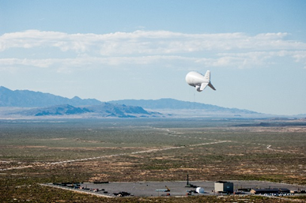

RAID Meets the Challenge

Sharon Watkins Lang
USASMDC/ARSTRAT Historical Office

In January 2003, the Army validated a requirement for enhanced force protection and situational awareness for coalition forces engaged in Operation ENDURING FREEDOM. The goal was to address the issue of indirect fires which were adversely impacting each unit’s ability to provide adequate security for airfields and forward operating bases. The units sought an enhanced capability to detect and identify threat movement at sufficient distances to enhance tactical decision-making.
The Joint Land Attack Cruise Missile Defense Elevated Netted Sensor System (JLENS) Project Office, part of the Program Executive Office for Air and Missile Defense, responded to this call with “a low-cost material solution to fill this operational need.” The JLENS team recommended the Rapid Aerostat Initial Deployment or RAID system. Composed of commercial-off-the-shelf technology, the RAID was equipped to meet the requirements and could be fielded quickly. In fact, the first systems were fielded in Afghanistan in March 2003.
A modified version of the JLENS, the RAID concept incorporated a 150-pound payload two easily transportable formats - 15-meter aerostats, which can hover at about 1,000 feet, and 117 foot trailer-mounted, collapsible towers, surplus communications equipment. The payload included two types of sensor/communications suites controlled via a fiber-optic link from the ground, where soldiers manning the ground terminals could record and/or transmit the data to other facilities. These sensors, an electro-optic color daytime camera, an infrared black & white or night camera provided around the clock, 360-degree visual coverage of the area for surveillance and force protection against small arms, mortar, and rocket attacks. A laser range finder with pointing azimuth indicator further enhanced capabilities, enabling personnel to locate targets of interest to approximately 13 km for personnel and 20 km for vehicles. In addition, the communications equipment extended the range of the Single Chanel Ground and Airborne Radio Systems by providing a retransmission capability.
The initial RAID contract was awarded to Raytheon Systems on 31 January 2003. One year later on 7 January 2004, the JLENS Project Office received additional funding for 18 new RAID systems (16 towers and two aerostats). This new iteration included upgraded tower systems and improved software which “provided significantly enhance operational perspective.” Within weeks, the first shipment had left Redstone Arsenal en route to Iraq. The initial installment for this AOR was declared operational on 26 January 2004, two weeks ahead of schedule.
By mid-2009, more than 300 RAID towers and over 60 aerostat systems were fielded as part of the Persistent Surveillance and Dissemination Systems in Iraq and Afghanistan, “safeguarding forward operating bases (FOB), improving surveillance in day and night and accelerating response to evolving threats.”

